A signed copy of this form must be submitted with every assignment.
If the statement is missing your work may not be marked.

Student Declaration

I confirm the following details:

Candidate Name: | Edem Angel Edem Hogan
Candidate ID Number: | P0013366
Qualification: | Level 4 Diploma in Computing
Unit: | Designing and Developing Object-Oriented Computer Programs (1148-1)
Centre: | AfriHUB
I have read and understood both NCC Education’s Academic Misconduct Policy and the Referencing and Bibliographies document. To the best of my knowledge my work has been accurately referenced and all sources cited correctly.
I confirm that this is my own work and that I have not colluded or plagiarised any part of it.
Candidate Signature: | Edem Angel Edem Hogan (typed; sign the paper copy)
Date: | 7 October 2026

Designing and Developing Object-Oriented Computer Programs
Paper 1148-1 · Fitness Tracker
Edem Angel Edem Hogan
NCC Education ID: P0013366
Centre: AfriHUB
7 October 2026
Word count (Tasks 2a, 2b and 3): 1498

Contents
Statement and Confirmation of Own Work
Task 2a — Test plan
Task 2b — How the data was selected and executed
Task 3 — Class design justification
Appendix A — Figure 1 class diagram
Appendix B — Test scripts and results
Appendix C — Graphical interface shots
References

Task 2
You will need to develop a test plan and implement it. You should write a five hundred (500) word report about the plan, which should include the test plan, the purpose of each test, together with test scripts, and the testing results with full details. An additional five hundred (500) word discussion should be included to justify how the data was selected and executed.

Task 2a — Test plan
The plan follows the required actions of the program. It covers registration, sign-in, goal setting and activity recording. It also covers total calories and whether a goal has been met. Each case states an input and an expected outcome before the run. The observed result can then be compared fairly. The plan is not a product description. It is a list of checks that another person can repeat.
Registration needs valid and invalid inputs. A valid username contains letters and numbers only. A space or punctuation mark must fail. An empty username must also fail. A password must contain exactly twelve characters. It must include at least one uppercase letter and one lowercase letter. The brief does not require a number or a punctuation mark, so Abcdefghijkl is a valid sample. Eleven characters and thirteen characters test the length boundaries. A twelve-character lowercase sample tests the missing uppercase rule. A twelve-character uppercase sample tests the missing lowercase rule.
Account tests also check duplicate names. Case differences must not create two accounts for the same name. A password failure must not leave a half-saved account. Closing and reopening the program must preserve a valid account. That check uses the JSON store rather than the form, because this Linux machine cannot run the Windows Forms shell.
Sign-in tests use correct and incorrect credentials. Five failed attempts trigger a thirty-second lock. The lock is stored with the user record. A later valid attempt must remain blocked until the stored expiry has passed. Success then resets the failed-attempt count. Unknown users and wrong passwords share one message so that the program does not reveal which field was wrong.
Activity tests cover all six activities. Walking uses steps, distance and time. Swimming uses laps, time and average heart rate. Running, cycling, jump rope and weights complete the set. Each activity has three labelled metrics. Zero duration, a heart rate of ten, and an impossible walking stride must throw an argument exception. A rejected record must leave the stored total unchanged.
The calorie checks use independent arithmetic. Walking and running use the ACSM walking and running oxygen-cost equations (Glass and Gregory, 2007). Swimming, cycling, jump rope and weights use Adult Compendium MET values chosen from the recorded pace or volume (Herrmann et al., 2024). The demonstration assumes a 70 kg reference person. The output is an estimate. It is not a medical measurement.
Goal tests cover totals below, equal to and above the target. Equality must count as achieved. A saved goal must remain linked to its account. Another account must not see the first account’s activity list. A restart must preserve both the goal and the records.
The attached script table supplies the repeatable actions. Expected results are not treated as executed results until a recorded run exists. The C# library was compiled and tested on this machine. Six xunit tests passed. A GTK host of the same form was then run on this Linux machine. Appendix C records that run. A Visual Studio run on Windows is still required before the USB is handed in.

Task 2b — How the data was selected and executed
Test data was chosen to challenge the stated rules. A typical valid value checks the normal route. A value on a boundary checks the exact rule. A value outside the boundary checks rejection. These three groups are needed because normal input alone hides many defects.
The username sample includes Alex01 and Maya7. It also includes Alex 01 and an empty string. The valid names use letters and numbers. The invalid name introduces a space. A repeat of alex01 after Alex01 checks case-insensitive duplication. The account rule should reject it if Alex01 already exists.
The valid password sample is Abcdefghijkl. It contains twelve characters. It includes both required letter cases. It has no digit and no punctuation, which the brief does not demand. The short sample Abcdefghijk removes one character. The lowercase sample abcdefghijkl lacks an uppercase letter. These cases isolate each requirement. A test that demanded punctuation would have been a test of the wrong rule.
The activity dataset covers six classes. Walking uses 4000 steps, three kilometres and thirty minutes. That combination gives a 0.75 m stride, which sits inside the accepted 0.35–1.20 m range. Swimming uses twenty 25 m laps, thirty minutes and a heart rate of 120. The pace is about 18 yards per minute, so the recreational freestyle MET of 5.8 applies. Running uses five kilometres, thirty minutes and no elevation. Cycling uses ten kilometres in thirty minutes, which is about 12.4 mph, so the 8.0 MET band applies. Jump rope uses 2000 jumps in ten minutes. Weights uses three sets of twelve repetitions in twenty minutes. These are practice values. They are not observations about a real person.
The calorie comparison uses an independent Python oracle. For walking, the ACSM walking equation at 100 m·min−1 gives a VO2 of 13.5 ml·kg−1·min−1. For a 70 kg person over thirty minutes that is 141.75 calories. Running at 166.7 m·min−1 gives 386.75 calories. The remaining four activities use MET × 3.5 × 70 ÷ 200 × minutes. The C# library must show the same six results after rounding to two decimal places. A different activity, or a different pace band, should change the result. The test checks the equation. It does not validate an individual’s physiology.
Rejected input must not change a stored total. A walking record with 100 steps over three kilometres fails the stride check. A swim with a heart rate of 10 fails the 40–220 bpm range. A run with zero minutes fails the duration check. Each of those cases must throw ArgumentException.
Persistence tests use two accounts. Alex01 receives a goal of 141.75 and one accepted walking record. Maya7 receives a goal of 500 and no records. After a fresh load from the same folder, Alex01 still has one record and an achieved goal. Maya7 still has a zero total. The users remain separate.
Execution used a local .NET 8 SDK in .tools/dotnet. The command was dotnet test on the class library. Six tests passed and none failed. The oracle wrote evidence/oracle.json. The same form was then opened through a GTK host on this Linux machine. Figure 4 shows a short password rejected. Figure 5 shows a valid account created. Figure 7 shows Walking 4000 steps, 3 km and 30 minutes producing 141.75 calories against a goal of 100. A Windows Visual Studio run is still outstanding.

Task 3
Develop a fully detailed class diagram, which should be accompanied by a five hundred (500) word justification of the design of your classes. Note that you are not allowed to use any tools that automatically build class diagrams.

Task 3 — Class design justification
The design separates the interface from the account rules. TrackerForm displays controls and results. AccountBook owns registration, sign-in, goals and records. FileCabinet owns reading and writing the data file. Activity owns the shared calculation contract. Rules holds the username, password and goal checks. Each class therefore has one purpose.
Encapsulation means keeping a class’s internal state controlled. AccountBook does not expose password hashes for ordinary editing. Its methods check the rules before they save a change. The form cannot set a user’s total directly. It asks the service to record an accepted activity. The data and the rules stay together.
Passwords are stored as salted hashes. A salt is a unique random value. The program derives the hash through PBKDF2-SHA256 with 210000 iterations (Microsoft, n.d.-a). It does not store the password itself. A later sign-in compares the derived value in fixed time. A normal text equality check would leak timing information and would also compare the wrong thing.
Activity is abstract. An abstract class supplies a contract without representing a complete activity by itself. Each concrete class identifies its labels and its calorie rule. Walking and Swimming keep the required metrics from the brief. Running, Cycling, JumpRope and Weights add the other four activities. Walking and running share the VO2-to-calorie conversion. The MET activities share the MET-to-calorie conversion. The equation is shared because the conversion is shared. The intensity choice is not shared, because that is what differs.
This inheritance is narrow. It is useful because the six classes vary in a stable way. A large class hierarchy would add work without changing the required behaviour. The design therefore does not create a subclass for every possible intensity. Walking rejects an impossible stride. Swimming and cycling choose a published MET band from pace. Those checks belong in the activity that owns the metrics.
The class diagram shows relationships as well as names. TrackerForm uses AccountBook. It also uses Activity objects when the user records a session. AccountBook uses FileCabinet. It holds many User objects. A user can own several activity records. Each record belongs to one user. Stored data does not become public merely because the interface can display it. Figure 1 was drawn as rectangles and lines. It was not generated from the source.
Loops support repeated work. The form loops through the three metric controls. The service sums the user’s records. Selections handle the chosen activity and the validation outcomes. These structures remain small. A long chain of copied calculations would make a correction harder to apply.
FileCabinet writes through a temporary file. A completed write then replaces the old data file. This reduces damage from an interrupted save. A missing file starts an empty list. An empty or invalid file throws InvalidDataException. The store does not replace a corrupt file with silence.
Windows Forms provides the required graphical interface (Microsoft, n.d.-b). Labels sit above their fields. Feedback uses one status area. The selected account is shown clearly. The design is suitable for an educational desktop application. It is not a substitute for a secure multi-user service. The source and the diagram must stay aligned if the program changes.

Appendix A — Class diagram
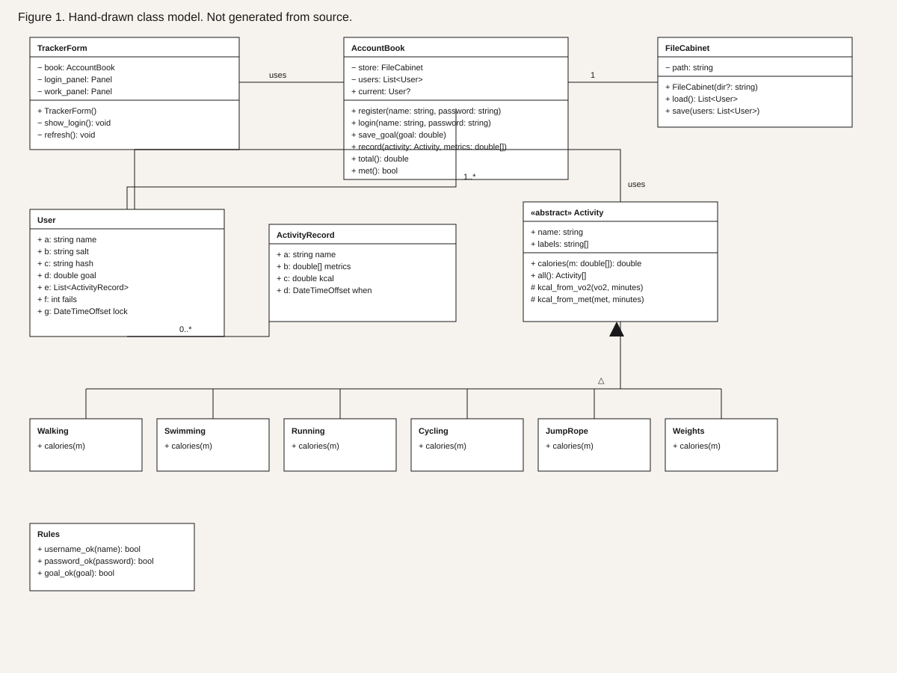 Figure 1. Hand-drawn class model. Not generated from source. + public, − private, # protected.

Appendix B — Test scripts and results
These tables are not part of the 1500-word count.
Table 1. Calorie oracles for a 70 kg reference person.
Activity | Inputs | Expected kcal | Oracle | C# test
Walking | 4000 steps; 3 km; 30 min | 141.75 | Pass | Pass
Swimming | 20 laps; 30 min; 120 bpm | 213.15 | Pass | Pass
Running | 5 km; 30 min; 0 m | 386.75 | Pass | Pass
Cycling | 10 km; 30 min; 110 bpm | 294.00 | Pass | Pass
Jump rope | 2000 jumps; 10 min; 140 bpm | 134.75 | Pass | Pass
Weights | 3 sets; 12 reps; 20 min | 85.75 | Pass | Pass
Table 2. Account, reject and persistence cases.
Case | Input or action | Expected | Result
C01 | Password Abcdefghijkl | Accept | Pass
C02 | Password abcdefghijkl | Reject missing uppercase | Pass
C03 | Password Abcdefghijk | Reject length 11 | Pass
C04 | Username Alex 01 | Reject space | Pass
C05 | Register alex01 after Alex01 | Reject duplicate | Pass
C06 | Five failed logins, then valid password | Still locked | Pass
C07 | Walking 100 steps, 3 km, 30 min | Reject stride | Pass
C08 | Swimming heart rate 10 | Reject | Pass
C09 | Running time 0 | Reject | Pass
C10 | Goal equal to walking total 141.75 | Goal achieved | Pass
C11 | Second user Maya7 after reload | Separate empty log | Pass
C12 | Linux GTK host: register Shot01, walk 4000/3/30 | 141.75 recorded; goal 100 achieved | Pass — Figure 7
C13 | Visual Studio WinForms on Windows | Project opens and runs | Not run here
C# result line: Passed! Failed: 0, Passed: 6, Skipped: 0, Total: 6. SDK 8.0.425. Linux GTK shots are Figures 2–7. Visual Studio on Windows is still required for the USB.
Written section count: 1498 words. This count includes the three task discussions and their headings. It excludes the title page, contents, tables, figure captions and the reference list.

Appendix C — Graphical interface shots
These figures are from the Linux GTK host of the same form. They are not a Visual Studio run.
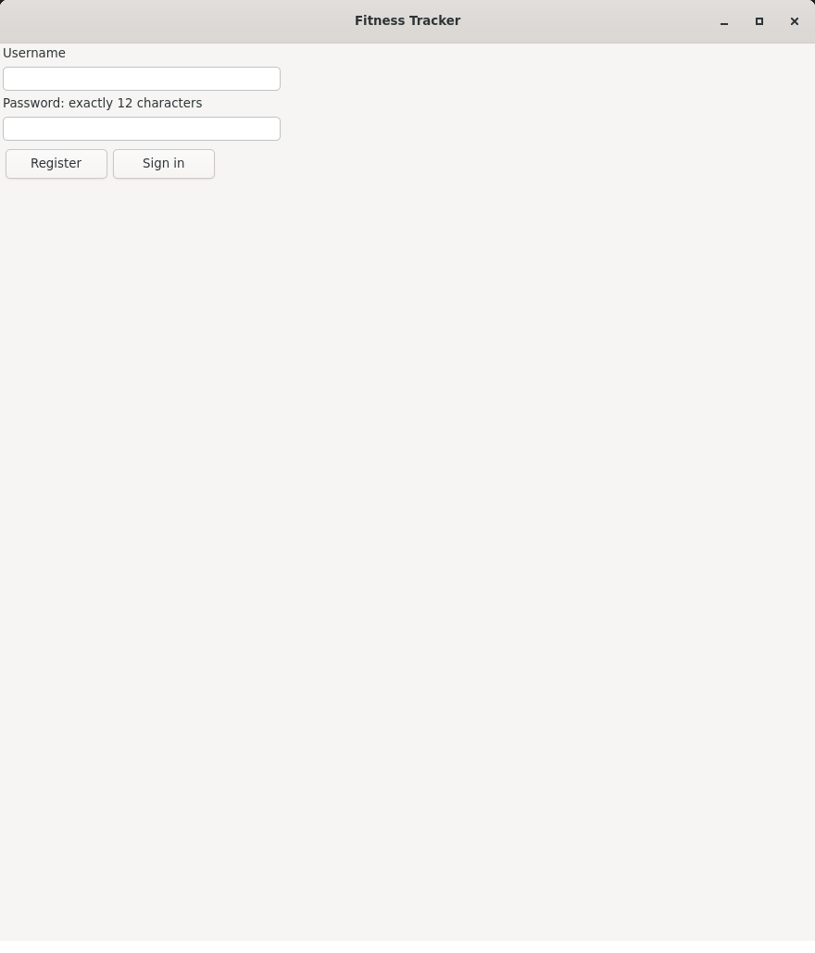 Figure 2. Login page with username, password, Register and Sign in. 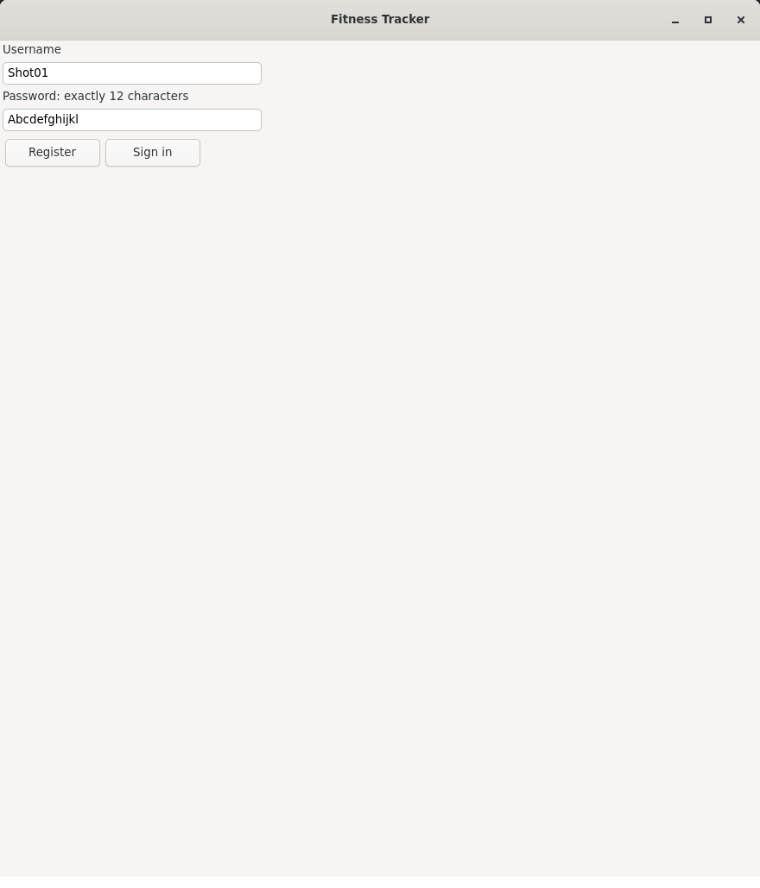 Figure 3. Valid sample ready to register: Shot01 / Abcdefghijkl. 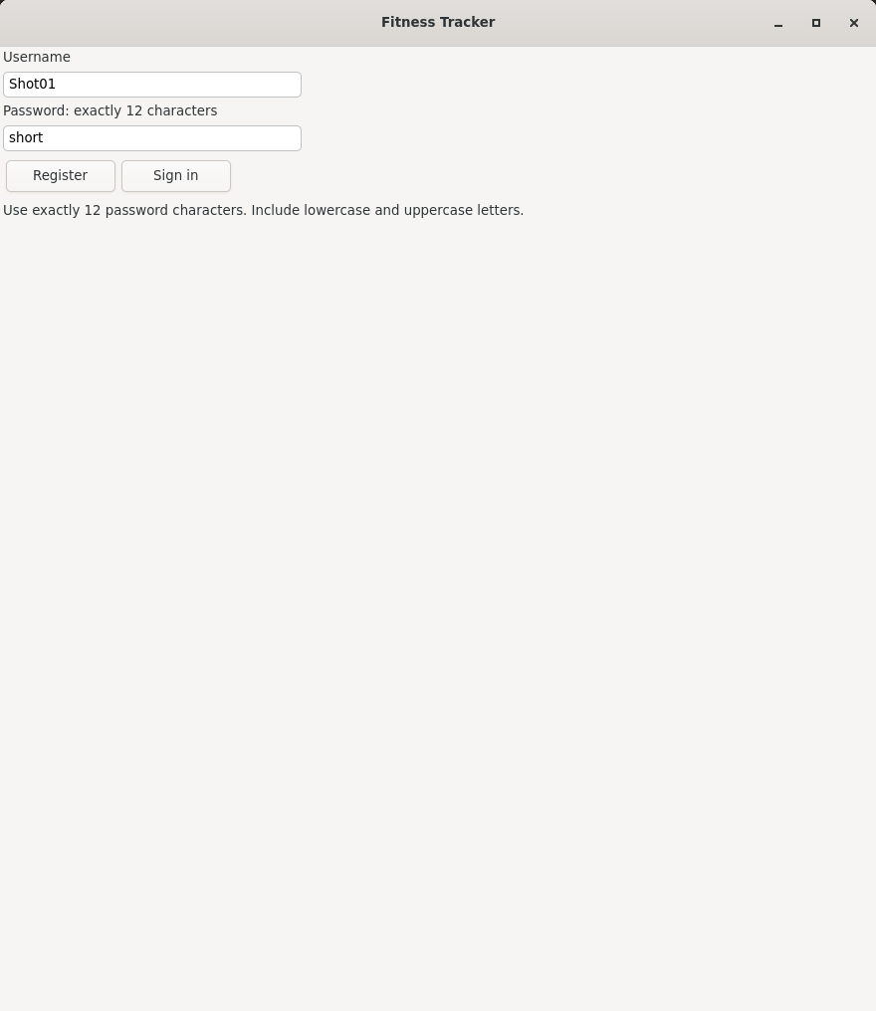 Figure 4. Password short is rejected. 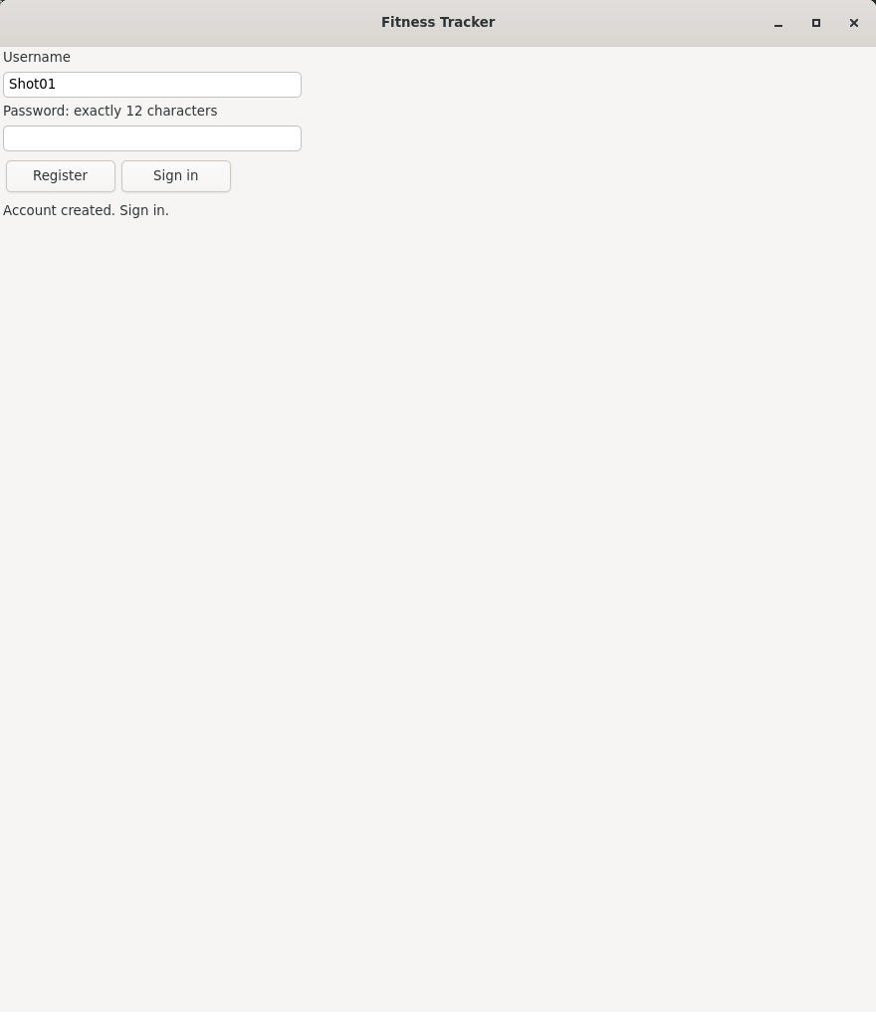 Figure 5. Account created. Sign in. 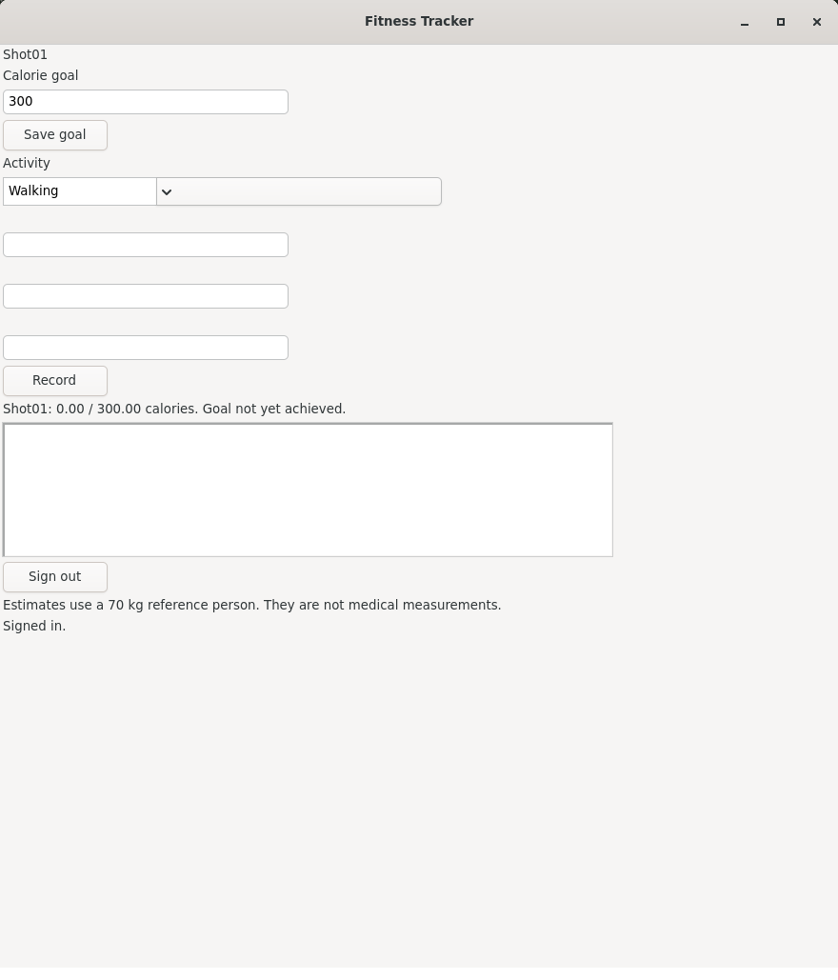 Figure 6. Signed in. Goal 300. Total 0. Goal not yet achieved. 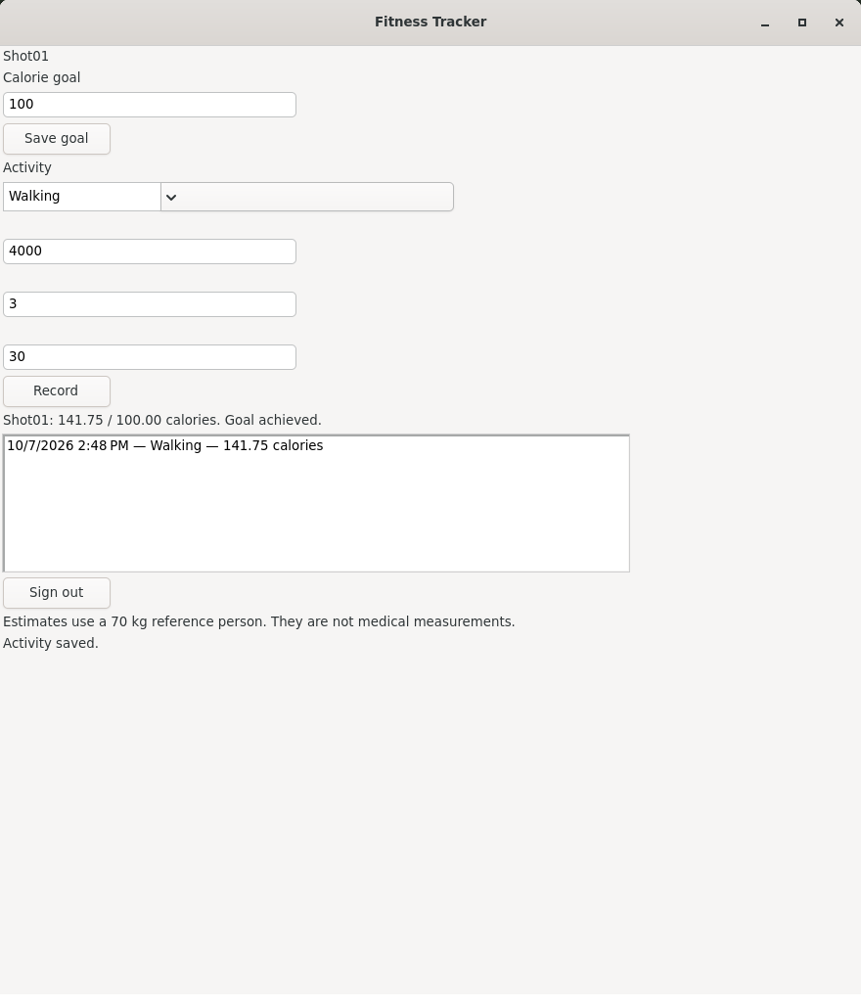 Figure 7. Walking 4000 steps, 3 km, 30 minutes = 141.75 calories. Goal 100 achieved.

References
Glass, S. and Gregory, B. (2007) ACSM's Metabolic Calculations Handbook. Baltimore: Lippincott Williams & Wilkins.
Herrmann, S.D., Willis, E.A., Ainsworth, B.E., Barreira, T.V., Hastert, M., Kracht, C.L., Schuna Jr., J.M., Cai, Z., Quan, M., Tudor-Locke, C., Whitt-Glover, M.C. and Jacobs, D.R. (2024) 2024 Adult Compendium of Physical Activities: A third update of the energy costs of human physical activities. Journal of Sport and Health Science, 13(1), pp. 6–12. Available at: https://pacompendium.com/ (Accessed: 7 October 2026).
Microsoft (n.d.-a) Rfc2898DeriveBytes.Pbkdf2. Available at: https://learn.microsoft.com/en-us/dotnet/api/system.security.cryptography.rfc2898derivebytes.pbkdf2 (Accessed: 7 October 2026).
Microsoft (n.d.-b) Windows Forms documentation. Available at: https://learn.microsoft.com/en-us/dotnet/desktop/winforms/ (Accessed: 7 October 2026).

